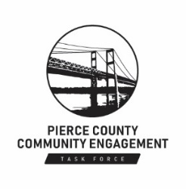
The Pierce County Community Engagement Task Force greatly appreciates your donation and generosity. Donations can be made by filling out this form and returning it to the Task Force or by contacting the Task Force directly.

Donation Form

Pierce County Community Engagement Task Force

Donor Information

Company (If Applicable)
First Name |  |  |  |  |  |  | Last Name

Address
City |  |  |  |  |  | State |  |  |  | ZIP Code
Phone |  |  |  |  |  |  | Email

Please direct my gift to one of the following areas:
- Community outreach
- Diversity, Equity, & Inclusion work
- Policy work
- Please use my gift wherever it is needed most

Payment Information
Please make checks payable to the Pierce County Community Engagement Task Force.
Check One: | □ Cash □ Check □ Debit or Credit Card □ Other

Card Number
Cardholder’s Name |  |  |  | Exp Date
Signature |  |  |  | Date Signed

Please accept my donation of | $

