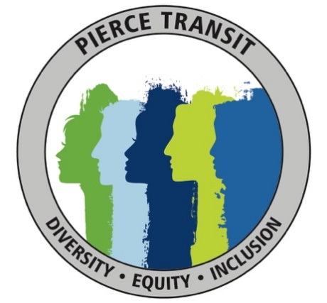
All Employee Diversity, Equity and Inclusion (DEI) Survey

Intent: To provide PT employees an opportunity to voice their ideas and/or
concerns regarding the agency’s Diversity, Equity, and Inclusion Program. This
survey will be utilized to conduct an analysis of gaps within the agency and
identify steps to mitigate these gaps.

Instructions: Please answer the questions below and drop the survey in the inbox
next to Employee Services’ door (located across the elevator of the Administration Building).

- What is your current age (in years)?

- Please indicate the gender/gender identity with which you identify.
  - Man
  - Woman
  - Transgender/Gender Non-Conforming
  - Non-Binary
  - Prefer not to answer

- Please indicate the racial or ethnic groups with which you identify. (Select all that apply.)
  - African American/Black
  - Asian American/Asian
  - Hispanic/Latino/a/x
  - Middle Eastern/North African
  - Native American/Alaskan Native
  - Native Hawaiian/Other Pacific Islander
  - White
  - Prefer not to answer
  - Other (Please specify): ________

- What is your highest level of education or certification?
  - High school diploma or GED
  - Two-year college degree (Associate’s)
  - Four-year college degree (Bachelor’s)
  - Master’s degree or higher
  - Certification:________________

- Which best represents your role at Pierce Transit?
  - Front-line staff
  - Supervisor/Manager
  - Executive Director

- How important do you think the DEI committee work is to Pierce Transit?
  - Low importance
  - Moderate importance
  - Very important
  - I don’t know what the committee does

- When you have new ideas and suggestions, do you feel comfortable speaking up? Do you feel your ideas are welcomed?

- What is the best way for you to share concerns or ideas with the DEI Committee?

- How satisfied or dissatisfied are you with the overall culture that you have experienced at Pierce Transit within the past 12 months?
  - Very dissatisfied
  - Dissatisfied
  - Neither Dissatisfied nor Satisfied
  - Satisfied
  - Very satisfied

- For the following pairs, check the box next to the characteristics which best describes the culture at Pierce Transit.
  - The focus is on getting straight to business Building relationships
  - Survival of the fittest Working together
  - Communication is blunt Diplomatic
  - Decisions are made from the top down Everyone has the opportunity to give input
  - There are rigid guidelines Creative thinking is encouraged
  - Focus is on immediate results Future growth

- I feel I belong at Pierce Transit
  - Strongly disagree
  - Disagree
  - Neither agree nor disagree
  - Agree
  - Strongly agree

- I have considered leaving Pierce Transit because I felt isolated or unwelcomed.
  - Strongly disagree
  - Disagree
  - Neither agree nor disagree
  - Agree
  - Strongly agree

- Pierce Transit provides sufficient programs and resources to foster the success of a diverse staff.
- Strongly disagree
- Disagree
- Neither agree nor disagree
- Agree
- Strongly agree

- I have to work harder than others to be valued equally at Pierce Transit.
  - Strongly disagree
  - Disagree
  - Neither agree nor disagree
  - Agree
  - Strongly agree

- How do you stay informed about career enhancement opportunities offered at Pierce Transit (career advancement, committee memberships, project involvement, etc.?

- What barriers make it challenging for you to achieve professional goals?

- During the past 12 months at Pierce Transit, how often have you interacted in a meaningful way with people who are of a different race or ethnicity than your own?
  - Never
  - Seldom
  - Sometimes
  - Often
  - Very often

- In general, over the past 12 months, have you felt that you have been negatively impacted by systems or policies at Pierce Transit due to your race, ethnicity, gender or gender identity?
  - Yes
  - No

- In general, over the past 12 months, have you felt that you have been negatively impacted by other employees at Pierce Transit due to your race, ethnicity, gender or gender identity?
  - Yes
  - No

- Do you notice or feel the effects of any form of racism, exclusion or otherwise “unequal treatment” in the following areas?
  - Allocation of resources/funding
  - Access to mentors/leaders
  - Training opportunities
  - Method of delivery of Training
  - Agency Policies
  - Agency hiring practices
  - Agency communication
  - Opportunity for advancement
  - Safe environment through which to bring up issues
  - Other (please explain:)___________________________

- Is there anything else you would like to share?

